Kingdom of Saudi Arabia  Ministry of Education  Eastern Province Education Department  Tarbeat Al-Ajial International Schools |  |  |  |  |  |  | Date: ……/………/..………  Subject: Computer  Grade: G5
……………… |  | Seat Number |  | ……………………………………….. |  |  |  | Student’s Name
2nd Semester Exam (2nd Session) 2025/2026
Sign. | Consultative Name |  | Sign. |  | Corrector’s Name | Marks in letters |  |  | Marks  in numbers
 |  |  |  |  |  |  |  |  | 40
Question A: Write the correct name of each part.
LIFT | DRAG | THRUST | GRAVITY
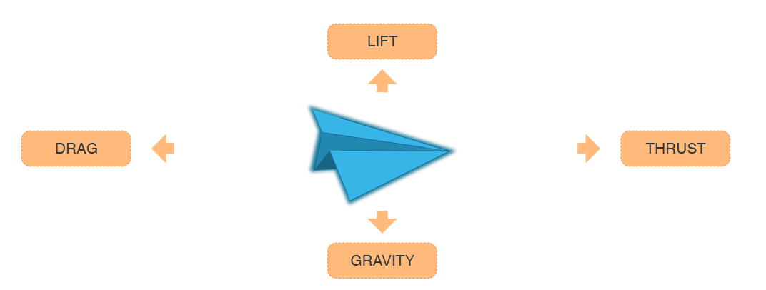
Quick access toolbar | Titlebar | Ribbon Menu
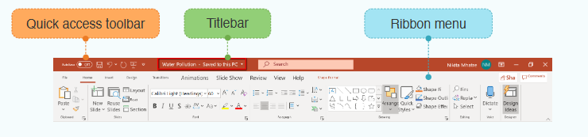
......................................
......................................
.......................

Question C: Fill in the blanks with the words in the box below.

Vertical | Cat | Horizontal

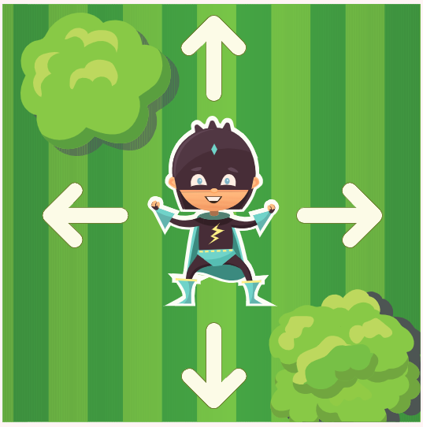
- Up or down movements are called ………………………
- Left or right ones
are called
……………..…………
Good Luck

Question B: State whether the statements are (True/False).
- Sprites are visual representations of an object.
- True b. False

- All events and actions for a game created in GDevelop are placed in the Event Sheet panel.
- True b. False

- The Launch preview button in the Top Menu is used to test the game.
- True b. False

- SmartArt is used to present large information in a short and effective manner with various shapes.
- True b. False

- Once SmartArt is used, it can be edited and modified to a different layout in the design tab.
- True b. False
Good Luck

